Programming Concepts - Tutorial 4
HIT265 – C Programming
Question 1
Apply Dijkstra’s Algorithm to each of the graphs in Figure 1. Don’t forget to include the table of vertex labels and the tree at each stage in your answer. In the graphs where no edge weights are given, assume an edge weight of 1 for each unlabeled edge. Remember to use the alphabetic/numeric convention – this will tell you which vertex to the algorithm at.
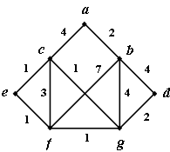
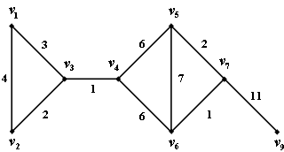
(a)
(b)

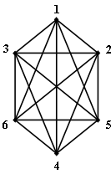
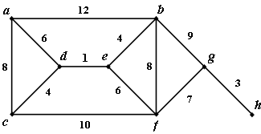
(c)
(d)

Figure 1
Question 2
What is the complexity of Dijkstra’s Algorithm?

